EXPENSE TRACKER WEBSITE

A MINI PROJECT REPORT

Submitted by

Group: G1

ANAS KHAN, 2410990836,
ANMOL SINGH SIDHU, 2410990842,
ABHEY GOYAL, 2410990814,

in partial fulfillment for the award of the degree of

BACHELEOR OF ENGINEERING

in

CSE



CHITKARA UNIVERSITY

CHANDIGARH-PATIALA NATIONAL HIGHWAY
RAJPURA (PATIALA) PUNJAB-140401 (INDIA)

SEPTEMBER 2024
ABSTRACT

This project presents an innovative Expense Manager website designed to simplify personal finance tracking and management for users of all ages. In an increasingly complex financial landscape, individuals often struggle to maintain awareness of their spending habits and budget effectively. Our platform addresses this challenge by providing a comprehensive tool that enables users to efficiently record, categorize, and analyze their expenses in real-time.

Key features of the Expense Manager include a user-friendly interface that promotes ease of use, ensuring that even those with minimal tech experience can navigate the site seamlessly. Users can input their expenses with just a few clicks, categorize them according to their preferences (e.g., groceries, entertainment, utilities), and set personalized budgets for different categories. The platform also offers advanced analytics, allowing users to visualize their spending patterns through interactive charts and graphs, facilitating a deeper understanding of their financial behavior.

Moreover, the Expense Manager incorporates budgeting tools that help users establish financial goals and track their progress over time. Personalized insights and alerts notify users when they approach budget limits, promoting responsible spending habits. Security is paramount, and the website employs robust data management practices to ensure users' financial information remains confidential and protected.

The platform's mobile responsiveness ensures accessibility on various devices, allowing users to manage their expenses on-the-go. By combining practicality with intuitive design, the Expense Manager aims to enhance user engagement and promote better financial literacy. This project not only addresses the common challenges of expense tracking but also empowers users to take control of their financial future, fostering informed decision-making and long-term financial wellness.

TABLE OF CONTENT

01 | INTRODUCTION | 4
02 | PROBLEM STATEMENT | 5
03 | TECHNICAL DETAILS | 6
04 | KEY FEATURE | 7
05 | PROJECT ADVANTAGE | 8
06 | RESULT | 9
07 | CONCLUSION | 10
08 | REFRENCE | 11

1-INTRODUCTION

In today’s fast-paced world, effective personal finance management is more crucial than ever. With rising living costs and the complexities of daily expenses, individuals often find it challenging to keep track of their spending habits and maintain a budget. The need for a reliable tool that simplifies expense tracking and promotes financial literacy is increasingly apparent.

This project introduces an innovative Expense Manager website designed to empower users to take control of their financial lives. Our platform provides a user-friendly interface that caters to individuals of all ages and backgrounds, making it easy to log, categorize, and analyze expenses in real-time. By integrating advanced features such as customizable budgets, detailed analytics, and personalized insights, the Expense Manager aims to transform the way users approach their finances.

The website not only enables users to monitor their spending but also fosters a deeper understanding of their financial behaviors. With interactive visualizations and goal-setting tools, users can make informed decisions that align with their financial objectives. Security is a top priority, ensuring that sensitive information is protected while maintaining a seamless user experience.

By bridging the gap between complex financial concepts and everyday spending, the Expense Manager seeks to equip individuals with the knowledge and tools necessary to achieve financial stability and success. This project represents a significant step toward enhancing financial wellness and fostering a culture of responsible spending.

2-PROBLEM STATEM ENT

Our Expense Manager website can address several real-world problems related to personal finance management:

1. Lack of Financial Awareness: Many people are unaware of their spending patterns. Your tool helps users visualize their expenses, allowing them to identify areas where they may be overspending.

2. Difficulty in Budgeting: Establishing and sticking to a budget can be challenging. Your website provides customizable budgeting tools that help users set financial goals and track their progress.

3. Time-Consuming Tracking Methods: Traditional methods, like manual entry or spreadsheets, can be cumbersome and error-prone. Your platform streamlines expense tracking, making it faster and more efficient.

4. Impulsive Spending: Without a clear picture of their finances, individuals may make impulsive purchases. Your site encourages mindful spending by providing alerts and insights into budget limits.

5. Financial Goal Setting: Many individuals struggle to set and achieve financial goals. Your website offers features that allow users to establish, track, and adjust their goals over time.

By addressing these issues, your Expense Manager website can significantly enhance users’ financial health and decision-making capabilities.

3-TECHNICALDETAILS

Code Edittor Used:-

Language Used:-

- HTML-HTML, which stands for Hyper Text Markup Language, is the standard markup language used to create and design documents on the World Wide Web. It forms the backbone of web content by structuring the elements on a web page and defining their relationships. HTML is a markup language that uses tags to define elements within a document. These tags provide instructions to web browsers on how to display and structure content.
Example:- div tags form tags ,table tags ,semantic tags etc

- CSS-CSS, or Cascading Style Sheet, is a style sheet language used for describing the presentation of a document written in HTML. In web development, CSS plays a crucial role in defining the visual presentation and layout of web pages.
CSS can be applied to HTML documents by linking an external stylesheet using the <link> element in the HTML <head> section or by using internal styles directly within the HTML document using the <style> element.
Example :- Colors, borders, grids, layouts, buttons etc

- Java Script-JavaScript is a versatile programming language primarily used for building interactive and dynamic content on the web.
JavaScript is mainly known as a client-side scripting language, meaning it runs in the browser of the user. This allows for dynamic and interactive features on web pages without the need for constant communication with the server

4-KEY FEATUERS

Here are some key features that we could highlight on your expense tracker website:

1. User-Friendly Interface: An intuitive design that makes it easy for users to navigate and log their expenses quickly.

2. Expense Categorization: Allow users to categorize expenses (e.g., groceries, utilities, entertainment) for better organization and tracking.

3. Budgeting Tools: Users can set monthly budgets for different categories and track their progress in real-time.

4. Real-Time Analytics: Provide users with visual insights through charts and graphs that display their spending habits over time.

5. Customizable Alerts: Users can set notifications for budget limits, upcoming bills, or unusual spending patterns.

6. Recurring Expenses: Feature to manage and track recurring expenses, making it easier for users to plan their budgets.

7. Mobile Responsiveness: Ensure the website is accessible and fully functional on mobile devices, allowing users to track expenses on-the-go.

8. Data Security: Highlight robust security measures to protect users’ sensitive financial information.

5-PROJECT ADVANTAGE

1. Better Budget Management
- Track Spending in Real-Time: With an expense tracker, users can log every transaction as it happens, providing up-to-date data on how much they have spent and what’s left in their budget.
- Prevent Overspending: By constantly being aware of spending levels, users are less likely to overspend because they know exactly how much they’ve allocated to each category (e.g., groceries, entertainment).
- Set Limits for Each Category: Users can assign a fixed amount to each spending category, such as $500 for rent, $300 for food, and the expense tracker will alert them when they approach those limits, helping to stick to their budget.

2. Financial Awareness
- Insight into Spending Habits: An expense tracker helps users to see exactly where their money goes. For example, it might reveal that they spend more on eating out than they realized, which gives them the opportunity to adjust those habits.
- Compare Monthly Spending: Users can track their spending over several months, allowing them to see trends (like seasonal spikes in spending) and adjust their budgets accordingly.
- Identify Wasteful Spending: By analyzing their expenses, users might find unnecessary subscriptions or habits they can cut down on, helping them save money over time.

3. Expense Categorization
- Organize Expenses into Categories: Your expense tracker likely allows users to categorize spending into different sections, such as bills, groceries, transportation, entertainment, etc. This makes it easier for users to see which areas of their life are costing the most.
- Customized Categories: Some users may have unique financial needs, like business-related expenses or savings for specific goals. Categorizing their expenses allows them to allocate their money accordingly.
- Simplify Financial Planning: With neatly organized categories, users can quickly review specific spending areas and plan their finances more effectively, instead of combing through random transactions.

6-RESULT
Welcome to Our Expense Tracker – Your Ultimate Tool for Financial Control and Clarity
Whether you're a budget-conscious individual, a savvy investor, or someone looking to improve your financial habits, our Expense Tracker is designed to meet your needs effortlessly. Our intuitive platform simplifies the process of managing your income, expenses, and savings, providing you with a clear, real-time view of your financial health.
With an easy-to-use interface, even beginners can start tracking expenses seamlessly. Whether you’re logging daily expenses, setting budget goals, or planning long-term savings, our tool is designed to adapt to your financial lifestyle.

Landing Page:-
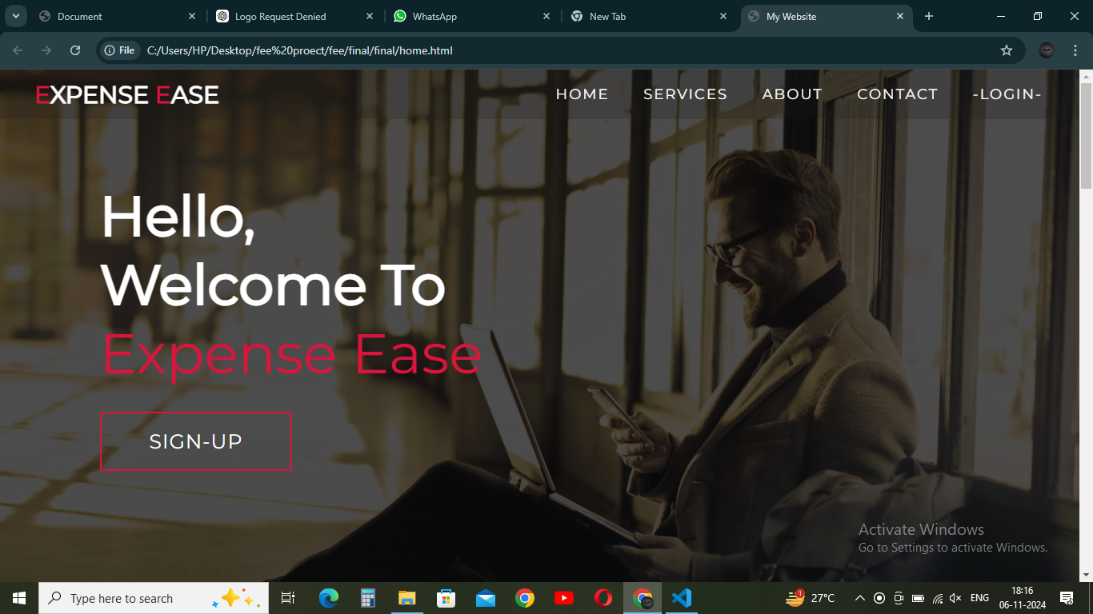
Fig-6.1

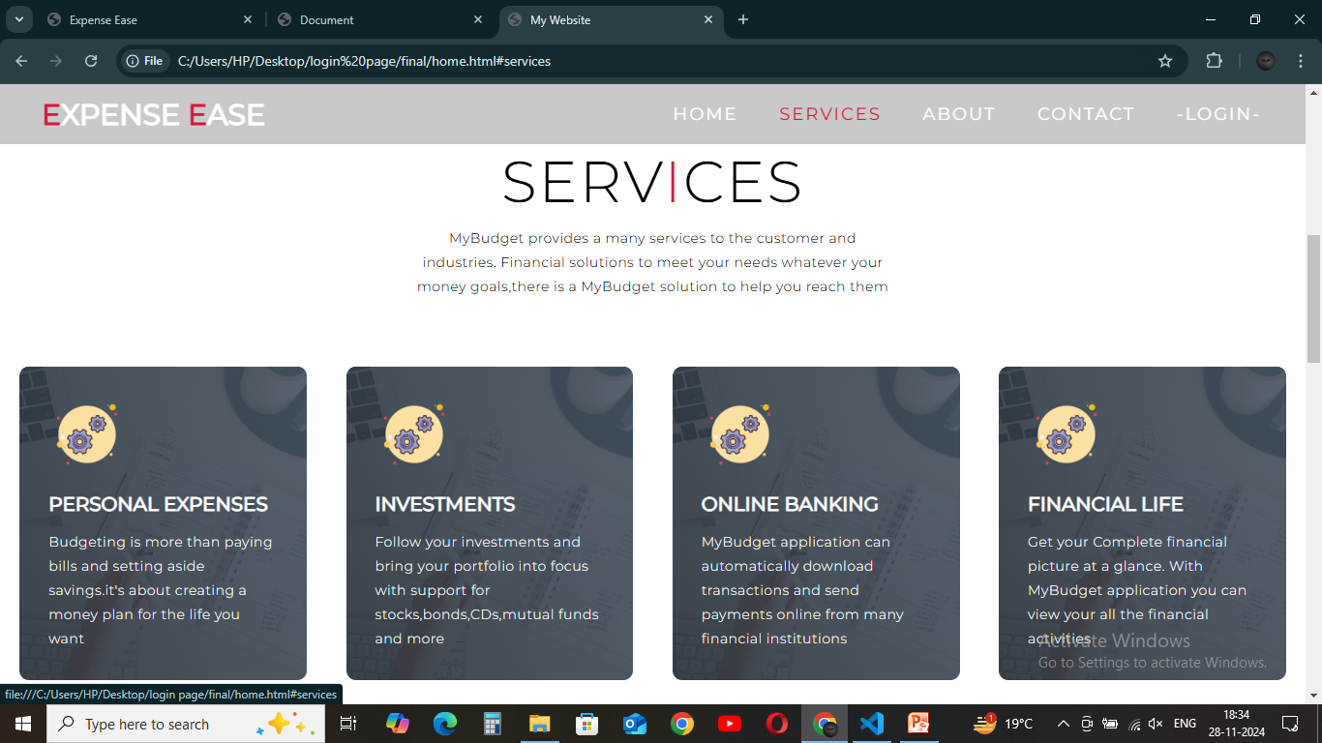
Fig-6.2

Login page:-
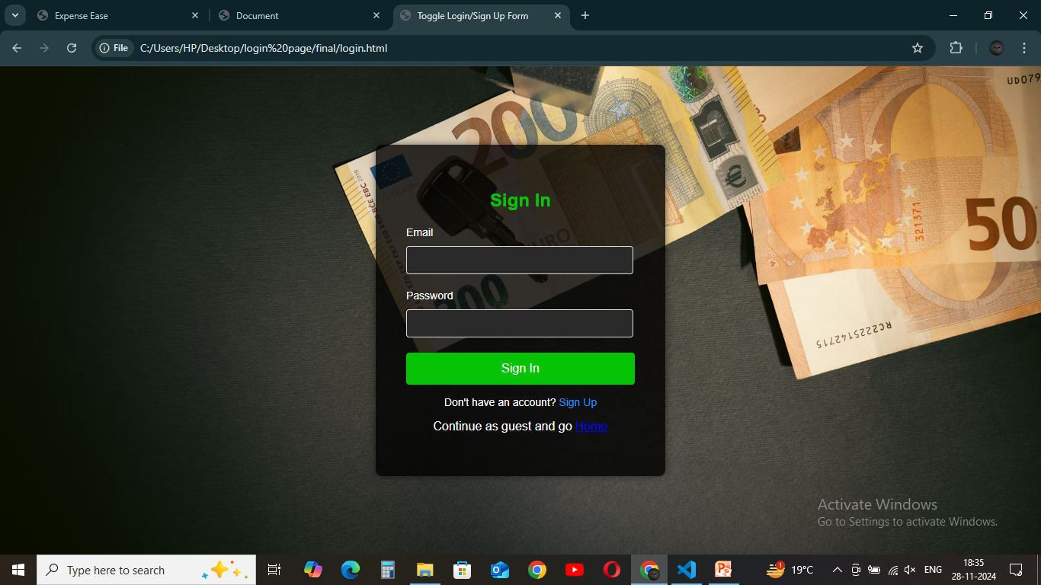
Fig-6.3

Home Page:-
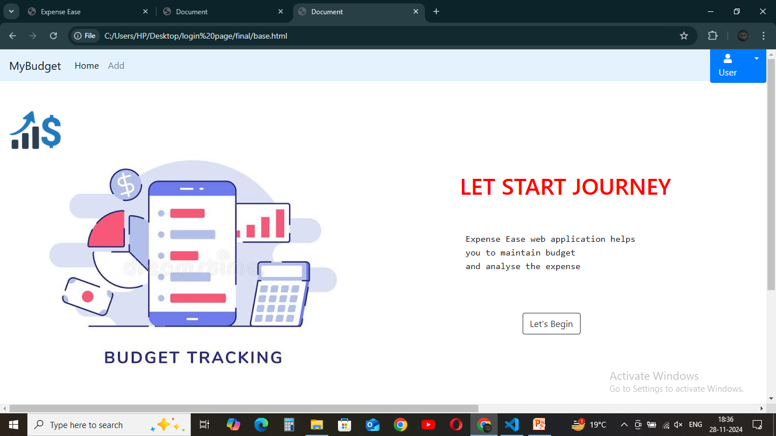
Fig-6.4

Application Page:-
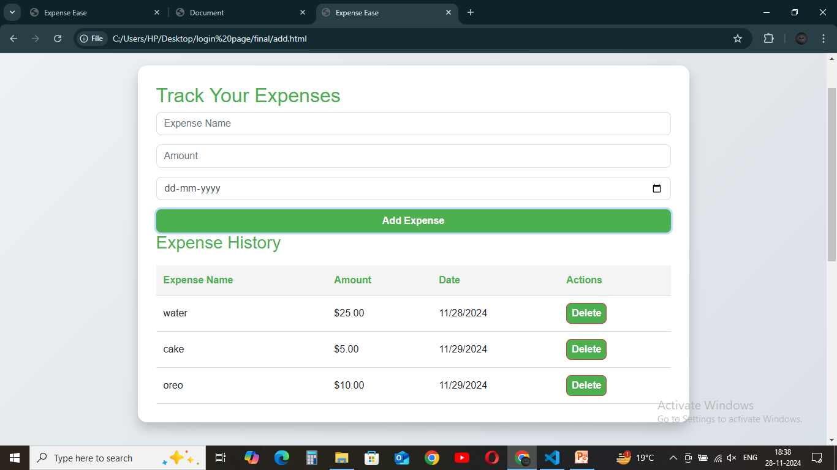
Fig-6.5

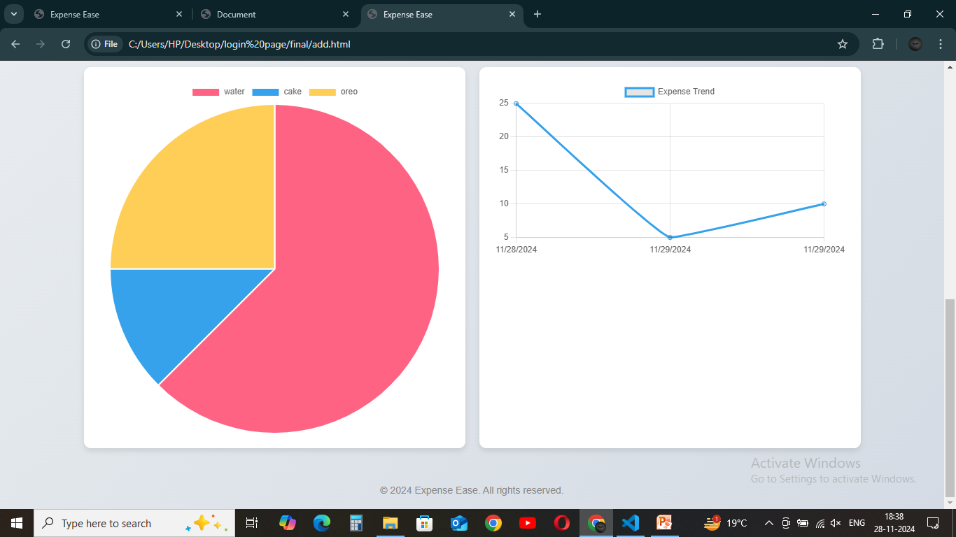
Fig-6.6

7-CONCLUSION

Our Group was very dedicated and excited towards this project. The main takeaways we get from this experience were-
- We learnt team spirit and coordination.
- We tried to overcome our weak-points and were able to help each other at certain areas.
- We found us getting excited witsh new possibilities at every corner, so we tried many ways to present our Project and have shown the bets one yet

8-REFRENCES

- www.geeksforgeeks.com
- www.youtube.com
- www.git-hub.com
- www.w3school.com
- www.bootstrap.com

